[](http://web.archive.org/web/)

|  |  |  |  |  |  |  |  |  |  |  |  |
| --- | --- | --- | --- | --- | --- | --- | --- | --- | --- | --- | --- |
| Top of Form    Bottom of Form | | |  |  |  | | --- | --- | --- | | [**FEB**](http://web.archive.org/web/20060213014816/http:/www.homeracingworld.com:80/fillin.htm) | **MAR** | [**JUL**](http://web.archive.org/web/20060707124524/http:/www.homeracingworld.com:80/fillin.htm) | | **[Previous capture](http://web.archive.org/web/20060213014816/http:/www.homeracingworld.com:80/fillin.htm)** | **28** | **[Next capture](http://web.archive.org/web/20060707124524/http:/www.homeracingworld.com:80/fillin.htm)** | | [**2004**](http://web.archive.org/web/20041206045517/http:/www.homeracingworld.com:80/fillin.htm) | **2006** | [**2007**](http://web.archive.org/web/20071017102218/http:/homeracingworld.com:80/fillin.htm) | |
| [**24 captures**](http://web.archive.org/web/*/http:/www.homeracingworld.com/fillin.htm)  12 Feb 2004 - 24 May 2013 |  |

[About this capture](http://web.archive.org/web/20060328024907/http:/www.homeracingworld.com/fillin.htm#expand)

[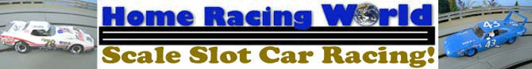](http://web.archive.org/web/20060328024907/http:/www.homeracingworld.com/index.htm)

***Fillin' The Gap***

***Easy Artin 4 Lane Modification***

A quick article to show how we used after-market material to join the 4 lane track system together.

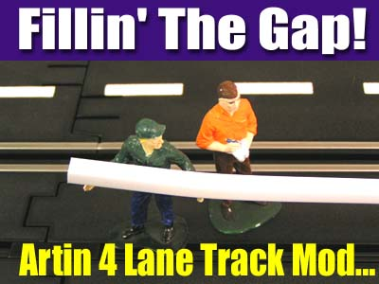

We chose Plastruct brand Styrene U channel Item # 90585 for this project. There are others you can use but this product is very close match to the standard Artin track clips and once we tested it, we were very pleased with the results.

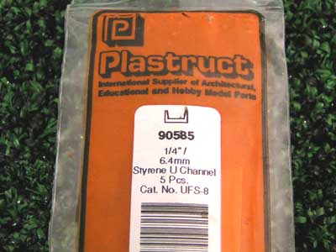 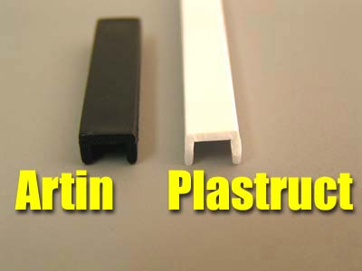

As you can see in the photo this material will work just fine for creating a continuous track joint. This is also ideal for use on the long straights or overpasses you might have on your layout.

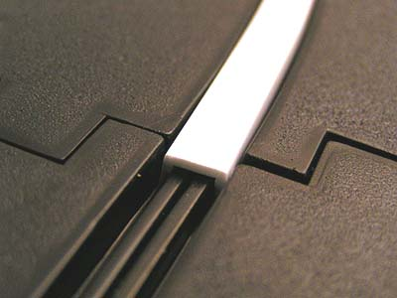 

You could use almost any type of adhesive to keep this in place but we prefer to use hot glue. This way it is easier to remove if you ever have to move the track or change your design. Just apply a small amount on top of the gap rails and then insert the plastic on top and hold for a few seconds, it will not take long for the hot glue to dry enough to hold it firmly in place.

 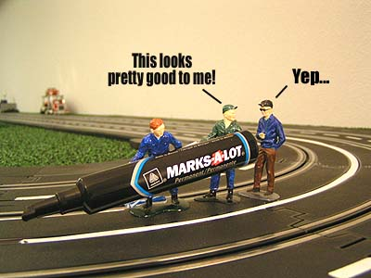

Now you could paint this material a flat black but we tried another method that gave us decent results. We used a common black magic marker and this seemed to blend the plastic right in. You could make it look even better by masking and painting the track but the black marker is close enough for most enthusiasts.

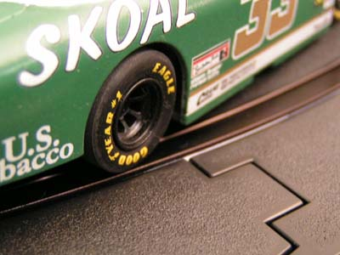 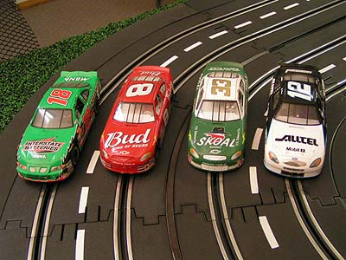

***And that is it, you are finished! This only takes a few minutes and the results are well worth the effort. Considering the value the Artin system brings me, I don't mind doing small projects like this to help increase the fun.***

***- Harry***

If you any questions, or need further help in this modification please feel free to [contact me](http://web.archive.org/web/20060328024907/mailto:harry@homeracingworld.com?subject=Power%20Supply%20Hook-Up). Our goal is to help you get the most out of your hobby so by all means let us know.

[Don't forget to join in the discussions on our Artin Message Forum!](http://web.archive.org/web/20060328024907/http:/pub44.ezboard.com/fhomeracingworldfrm2)

[](http://web.archive.org/web/20060328024907/http:/www.homeracingworld.com/index.htm)